(Approx. 533 words)

Open Source Lab
Keeping Up with Open Source
By Cal Esneault, former President of CCCC and leader of many Open Source Workshops & SIGs
Cajun Clickers Computer Club News, April 2016
www.clickers.org
tsa70785 (at) gmail.com

Once someone starts using open-source software, either by running a Linux OS or by installing cross-platform tools on Windows or Mac OS systems, the reality sets in that there is a whole new world of vast opportunities available without the drawbacks of financial cost or restrictive licenses. But how does one navigate this new environment? My personal advice is to use the DistroWatch.com site as a key resource. Besides being a jumping off point to find Linux distributions, it also has a great newsletter with links to current information. In particular, I like to keep up by reading recent newsletters and listening to the latest podcasts. Below is a sample of the left-hand pane on the DistroWatch web site that has links to newsletters and podcasts.

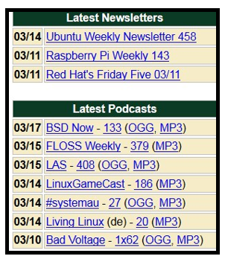

For newsletters, you can see the variety of platforms: Ubuntu, a Debian-based OS; Raspberry Pi, a single board computer using ARM processors; and, Red Hat, an RPM-based OS used in enterprise environments. The resources are listed chronologically, and the list changes with time as new issues are made available.

Podcasts (or netcasts, for purists), are audio files where there is a general discussion with recurring hosts typically focused on recent news items of interest to users of open-source programs. The two common audio coding formats, MP3 and OGG, provide "lossy" data compression which reduces file size while still providing sufficient dynamic range for conversational programming.

BSD Now and LAS (Linux Action Show) are both productions of Jupiter Broadcasting, an organization that has been producing audios and videos since 2008. From their studios in Washington State, they now produce ten shows, most produced weekly. In general, shows follow a news format covering recent events with a main segment of more in-depth coverage of a specific open-source software item.

FLOSS Weekly is a netcast produced by TWiT.tv, a company in central California started in 2005 with about two dozen weekly podcasts now being produced in both audio and video formats. FLOSS stands for "Free, Libre, and Open-
Source Software", and shows generally concentrate in depth on a particular application or set of software tools. Content is aimed at more experienced users.

Podcasts usually follow a pattern of style set by the hosts, and whether you like a particular show is very subjective for each individual. Prepare to take some time to sample a variety of podcasts before you find a set that meets your own views and needs. Here are a few other shows that may be of interest (many available in both audio and video formats):

- GNU World Order
- Hacker Public Radio
- Mintcast
- Linux Luddites
- Sunday Morning Linux Review
- Blender Podcast
- LinuxLUGcast
- Category 5 Technology TV

If this is not enough, go to the "Tech Podcast Network" site to view their list, or simply use your Internet search engine to search for new shows. Once you find a suitable list of shows that you personally like, you will have a continual flow of information and entertainment to keep you up to date.

